Name ___________________________

God’s Covenant People

God’s Promise of Salvation

And I will put enmity between you and the woman and between your offspring and hers he will crush your head and you will strike his heel. The meaning of this verse when Jesus dies on the cross he will come back and then strike for Satan’s head and Satan will strike for Jesus’ heel.
Gen 3:15

God’s Covenant with Noah
God’s Covenant with Noah will never to flood the Earth again.The fitting symbol is the rainbow it comes after the rain.

God’s Covenant with Abraham
God’s Covenant with Abraham is that his name will be great. He would be the father of the nations. He would have a lot of descents of the stars and sand.

Abraham was willing to sacrifice his one and only son and God was also willing sacrifice Jesus. They are diffanet because Jesus dies and Abraham was stopped so his son didn’t die.
God’s Covenant with Israel
If they kept the Covenant they will be his chosen people.
Out of all nations they his treasured possession.

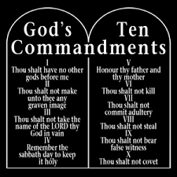
The people of Israel needed rules from God to obey.

God’s Covenant with David

Davids descendants would rule over the kingdom in Israel and Jesus would be in that descendants.

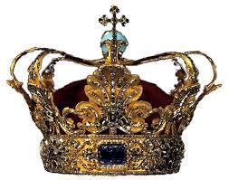
When Jesus Christ came in the world he established the kingdom.
God’s New Covenant with Israel and Judah
God put the new Ten Commandments in their minds and their hearts.

The old Covenant was on stone tablets.

