Young Fives and Kindergarten Families

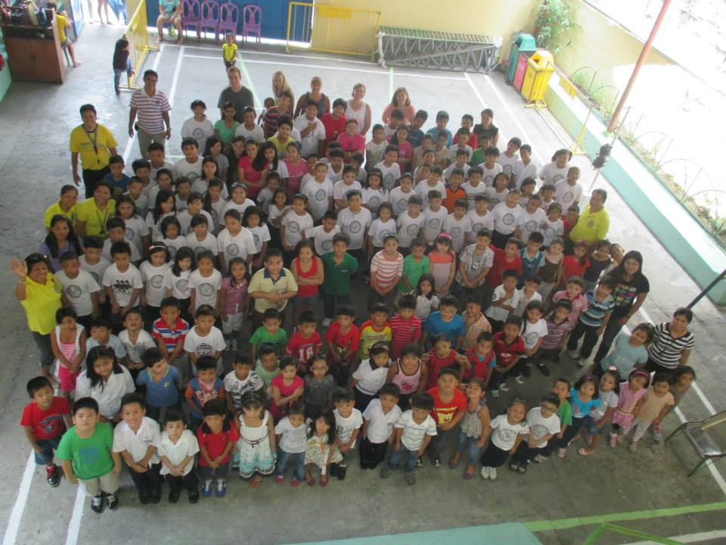
On Wednesday, November 3, we will be having a special chapel welcoming Pastor Leo and Elma Ordiales back to Zeeland Christian. Pastor Leo and Elma are dear friends from Grace Christian School in the Philippines. Grace Christian School has been our sister school in the Philippines since 1999. Many students and staff from Zeeland Christian have traveled to the Philippines and have been able to help build friendships between the schools that go beyond our special partnership. The Philippines has an educational system similar to the U.S. except that it is very poorly funded. It is common to see many children in a classroom with limited supplies. As you can well imagine, it is very different than Zeeland, Michigan. Another large difference is that children do not have the opportunities to hear about our Savior. Our sister school is trying to change all this by providing an education for children that not only includes a teacher and school supplies but also the message of Jesus Christ.
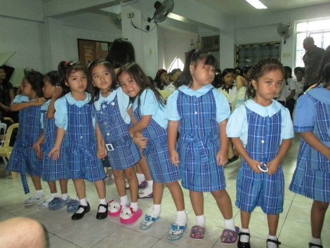
ZCS Young Fives and Kindergarten classes will be joining the first-grade class to work together to help pay the tuition cost of $500.00 for one child to attend Grace Christian School. The little girl we are sponsoring this year is Gabrielle Cinco. Gabrielle. Please see the attached sheet with information on Gabrielle and her family. As a family, please prayerfully consider if you are able to contribute to our sponsorship of Gabrielle.
We have chosen the month of November to collect money both because of the timing of the visit from Pastor Leo and Elma and because we think of Thanksgiving as a time of giving and giving thanks. While there is no obligation to give, there is also no amount to small. We will be collecting throughout the month of November and your contribution can be sent in at any time.

Thank you for partnering with us as we bless a child with the gift of Christian Education.

Love and Blessings

